PRESENTATION MODULE 5

CAMILO SOLER

1C SKILL CAMP 2021

MOBILE PLATFORM COURSE

FACATATIVA

2021

PRESENTATION MODULE 5

CAMILO SOLER

Presentation task

Delivered to 1C Mentor

1C SKILL CAMP 2021

MOBILE PLATFORM COURSE

FACATATIVA

2021

1. **Fruit S.A.**

Hi dear user, welcome to Fruit S.A, in this opportunity the company will build a new application, the app maybe has errors and the functionality is poor, but the important is this company have your application and this have patch to add functionality and fix bugs with this maybe have. Ok no more to say let’s continue with the presentation.

* 1. **Content.**

The app has different content all destiny about the company. Ok the important is the next.

* + 1. **Catalogs.**

The app have five catalogs that you can use, three are important about the content to the company. Workers this have the information about the workers to the company, Client contain the information about the person that buy something in the shop and Fruits this is important because is the company sells.

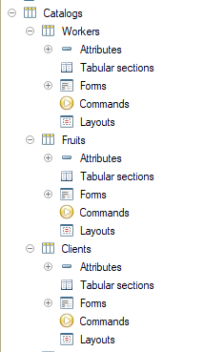

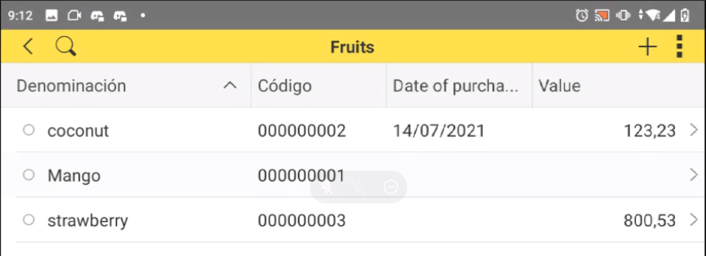 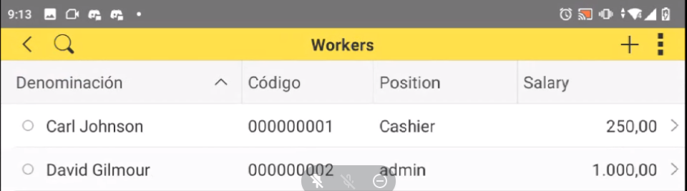

* + 1. **Documents**

The documents are only two Taxes, this is the valor that the company pay to the government and other persons that don’t your clients for Example IVA.

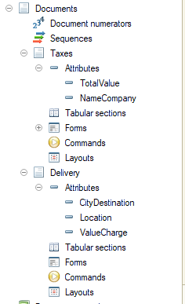

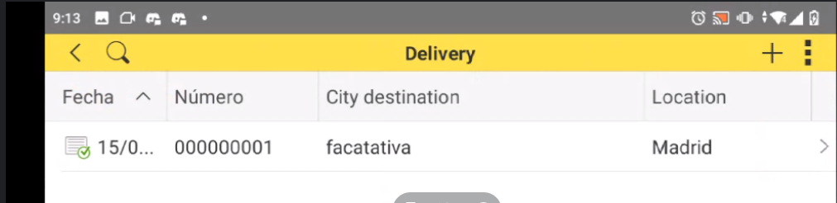 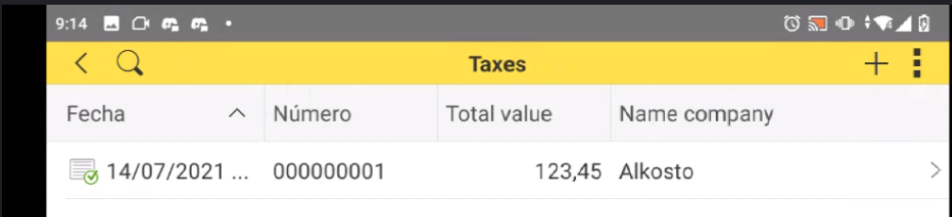

* + 1. **Accumulation register**

The company want know the valor of transactions in the taxes for this was created a accumulation register his name is Register Taxes this appear in the main menu and his contain the register about the taxes the company

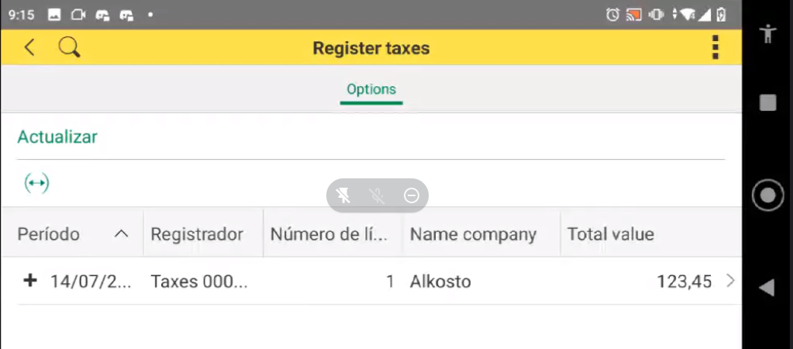

* + 1. **Android Functionality** 
       1. ***Multimedia.***

In the multimedia you can create only photos and videos that was saved in you phone, later explain more, the reason the company require the personal photo and a video about the state the shop

* + - 1. ***Scan Barcodes.***

For question ecologist the company don’t have physical receipt and don’t have labels, all is worker with Barcodes and QR codes, for this is implemented the use.

* + - 1. ***Contacts***

The company want know the information equal that Facebook, for this the company work with contacts because we create and use the numbers and the register is saved in the app, this used in order supplies principally.

* 1. **Presentation and functionality**

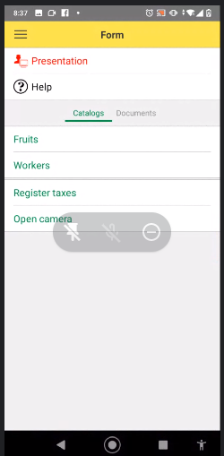 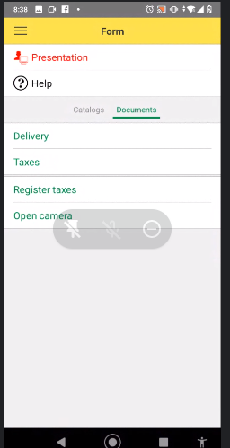

In the menu you can see this options, the presentation you can Know the father for this application and your objetive, next you can help that you can need use the app, next you can see the catalogs and the documents that all can edit, more down, appear the accumulation register Register taxes, this only work if you create a new register in the document taxes and open camera that you can take a pictures.

* 1. **How I can Takes photos.**

For this option have two options:

* Press the button open camera
* Fill all the information that you want (In this case I put the information that you can see in the picture.

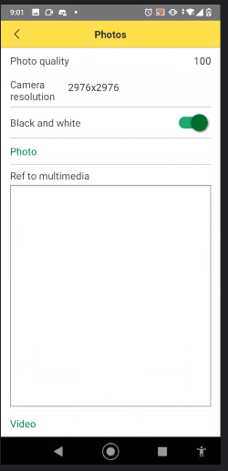

* Press the button photo and take a picture that you want

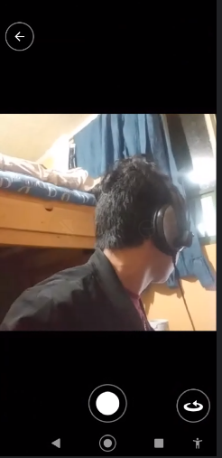

Save the photo and you can see in the page

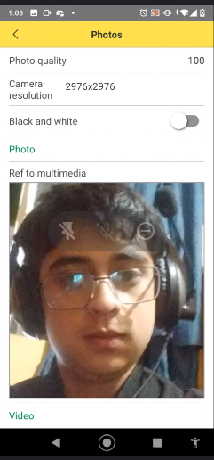

* The second option is used for the company, in the main menu press the button Workers and you go the workers catalogs.
* Next press the button open camera that you can see in the final in the formulary, later continue the steps tho the part 1

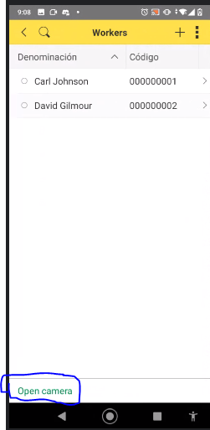 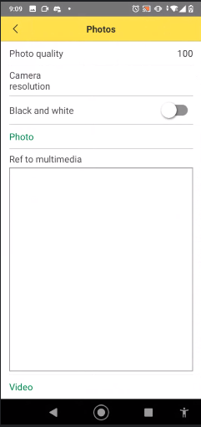

* 1. **How Can I take a video with the app.**

Ok is simple oly take this steps.

Step 1: Press the buttom “Open Camera”.

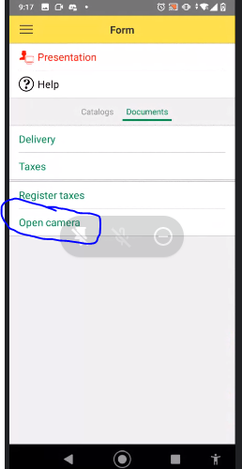

Step 2: Press the buttom Video.

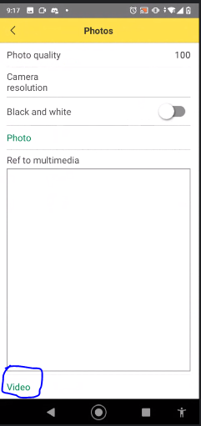

Step 3: Write a name that you want in “Android File Video Name” and next press the buttom Make android Video.

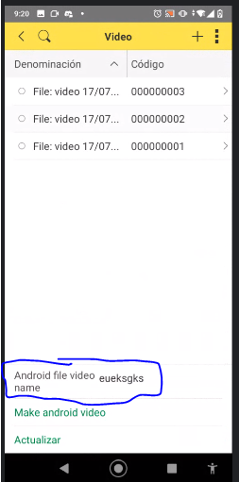 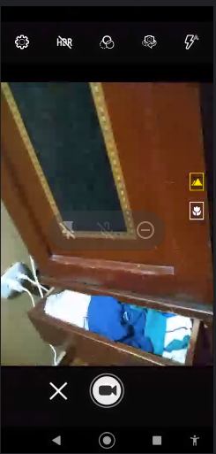

Finally save the video

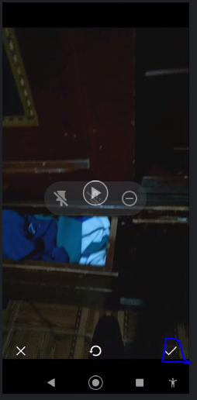

Next press the buttom Updateo Actualizar

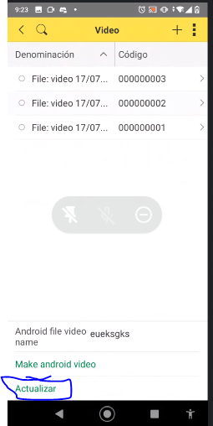

And as you can see a new file was generated, open then.

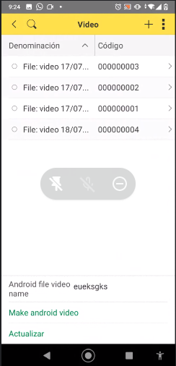 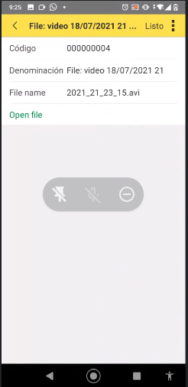

The video was recording in format .Avi but if you want this be mp4 you write me and I take for the next time, if you press the button open file you open the galery and see the video

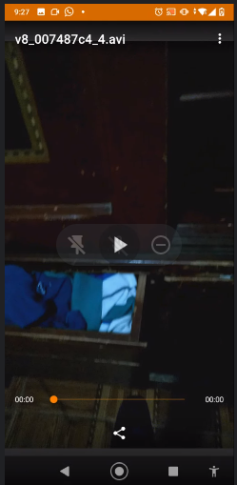

* 1. **How can I use the Scanner for Qr Code and Barcode.**
* First, Install the application Barcode Scanner

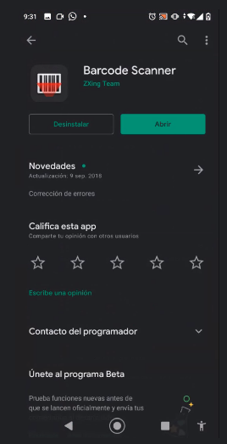

* Next to, open the catalog and create any product. 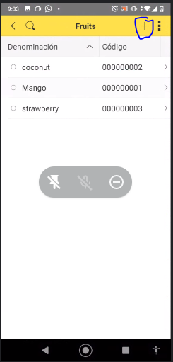
* Next press the button “Scan bar code”
* Fill all the items, if you want scannig a barcode in Barcodetype use EAN and UPC and Scanning Barcodetype write ean_13 or you want QR code search QR. And Scanning Barcodetype write Qr code, finally fill the data tha you want.
* 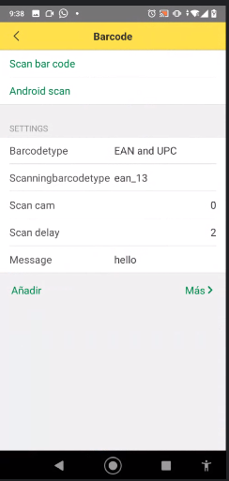
* Press the button Android Scan bar, in this case I scannig the book Crime and punishemed writing by Fiodor Dostoiesky.
* 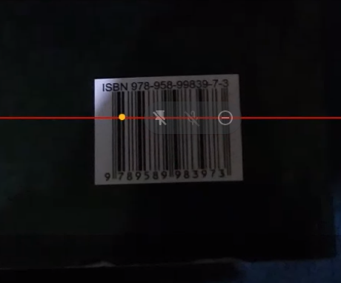 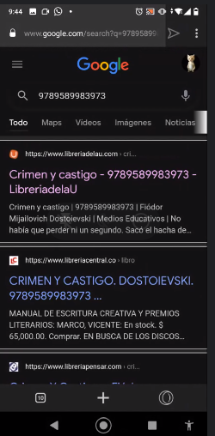
* Later, open automatly a table with the code

